**A TECHNICAL REPORT ON**

**STUDENT INDUSTRIAL WORK EXPERIENCE SCHEME (SIWES)**

**CARRIED OUT AT**

**BULAMA KING ENTERPRISE MARARABA,**

**HONG, ADAMAWA STATE**

**FROM: 4TH JANUARY, 2023**

**TO: 4TH MAY, 2023**

**BY**

**HABILA TIMOTHY**

**ST/CS/ND/21/048**

**SUBMITTED TO**

**THE DEPARTMENT OF COMPUTER SCIENCE**

**SCHOOL OF SCIENCE AND TECHNOLOGY**

**FEDERAL POLYTECHNIC MUBI**

**IN PARTIAL FULFILLMENT FOR THE AWARD OF NATIONAL DIPLOMA (ND) IN COMPUTER SCIENCE**

**JUNE, 2023**

**APPROVAL PAGE**

This is to certify that this report was compiled and written by HABILA TIMOTHY. with Registration Number ST/CS/ND/21/048 from the department of Computer Science of the Federal Polytechnic Mubi, Adamawa State and was read and approved by

**MR. SULEIMAN SANI**  _______________

School Supervisor Date

**MR. SIMON GALADIMA** _______________

Department SIWES Coordinator Date

**MALLAM ADAMU GARBA** ________________

Head of Department Date

**DEDICATION**

I dedicate this report to the Almighty God for the guidance and protection accorded me throughout the programme.

# ACKNOWLEDGMENTS

I thank God Almighty for making me to undergo students industrial work experience scheme (SIWES) successfully.

My gratitude goes to my parent for their prayers, financial and moral support during my attachment.

I also appreciate the kind gesture of my brothers and sisters and those who supports me in prayers and contribution during my industrial attachment.

I whole heartedly thank my Head of department Mallam Adamu Garba Mubi, SIWES coordinator and all lectures of Computer Science for their effort to ensure my success as their students.

I am greatly indebted to my co-SIWES students to mention, may God strengthen our relationship together and grant us academic excellence.

I sincerely thank you all for your contribution and support.

**ABSTRACT**

*The report summarises the result of work done during my SIWES experience, the technical report consists of four chapters, which comprises of introduction, history and criteria’s of SIWES in chapter one followed by their aims and objectives, historical background, organizational structure of the organization in chapter two, while chapter three consist of the work and experience gained during the SIWES programme and lastly chapter four consist of the summary, conclusions and recommendation.*

**Table of Contents**

**Title page - - - - - - - - - - i**

**Approval page - - - - - - - - ii**

**Dedication - - - - - - - - - - iii**

**Abstract - - - - - - - - - - iv**

**CHAPTER ONE**

1.0 Introduction - - - - - - - - - 1

1.1 Background of SIWES - - - - - - - 1

1.2 Brief History of SIWES - - - - - - - 1

1.3 Aims and Objectives of SIWES - - - - - 2

**CHAPTER TWO**

2.1 Brief History of the Organization. - - - - - 3

2.2 Mission Statement - - - - - - - - 3

2.3 Vision statement - - - - - - - - 4

2.4 Organizational Chart - - - - - - - 4

**CHAPTER THREE**

3.1 Computer Maintenance - - - - - - - 5

3.2 CorelDraw - - - - - - - - - 15

3.3 Microsoft Office Excel - - - - - - - 17

**CHAPTER FOUR**

4.1 Summary - - - - - - - - - 22

4.2 Conclusion - - - - - - - - - 22

4.3 Problems - - - - - - - - - 23

4.4 Recommendations - - - - - - - - 23

**CHAPTER ONE**

**1.0 INTRODUCTION**

The concept behind industrial training schemes is to acquire practical, knowledge in addition to what has been learn institution. The four months mandatory supervised industrial attachment is program instituted by the federal government to help student for their different field of studies.

**1.1 BACKGROUND OF SIWES**

It aims at exposing student to the practical and the actualization of work situation which they may meet after graduation and the learning is meanly expected to produce graduate qualification to meet man power of employments of (ITF), there was growing concern amount the industrialist that graduate of higher learning do not passes adequate background student for the opinion that theoretical education going higher institution was responsive enough to meet the need of employers of the labour as a requirement of national board for technical education (NBTE) polytechnic training before obtaining the National Diploma (ND).

Experience scheme (SIWES), is a National programme introduced by Government in 1974 for student in tertiary institution.

### 1.2 BRIEF HISTORY OF SIWES

**SIWES** was established by **ITF** in 1973 to solve the problem of lack of adequate practical skills preparatory for employment in industries by Nigerian graduates of tertiary institutions.

The program “Student industrial work experience scheme” is a pure skill-acquisition program structured for the tertiary institutions as a complementary and enhancement program to the theoretical education, laboratory and workshop practices engaged in by student in different higher institutions. The SIWES was initiated to improve the student’s technical abilities (performance/knowledge) and expose them to industrial culture thereby preparing them to be acquainted with the roles to play towards the technological advancement of the nation.

It is there for a practical aspect of the academic works, which the students may not be opportune to carry out throughout their stay in the higher institutions. Based on this fact, the Federal Government decided to establish a body (regulatory) which engages in the training of the technical manpower. The body is named industrial Training Fund (ITF). The government also undertook to make up for the deficiencies by structuring and established Students Industrial Training (SIT) as it was then called but in 1973 the SIWES was formed which is the subsidiary.

### 1.3 AIMS AND OBJECTIVES OF SIWES

1. One of the objectives of SIWES is to create an avenue for students to acquire industrial skills to complement their theoretical knowledge and improve their experiences in their course of study.
2. The program prepares the students for industrial working conditions prior to their graduation.
3. To enable the students to learn personal relationship with employers and co-employees on graduation.
4. It exposes the student to working methods and techniques in handling equipment and machinery.
5. It develops the student in make critical and realistic approaches to solving problem.
6. It serves as a way of improving the abilities of the students and to contribute to the growth of the nation.
7. It gives the students the opportunity to practice what they have been taught in various disciplines.
8. The SIWES program strengthens the employer’s involvement in preparing the students for employment.

**CHAPTER TWO**

**2.1 BRIEF HISTORY OF BULAMA KING ENTERPRISE**

Bulama King Enterprise, Hong was established in 2013, the Institute is the leading tech company that provides computer Education in the Development of Information Technology systems.

The company have graduated about 100 students and presently have over 20 registered students. For more than 9 years, the Institute has been a pioneer in the development of Information Technology in the State. With a crop of versatile professionals, cutting-edge course contents, enormous Hardware, Software and Computer facilities to mention just a few of the reasons top companies consistently choose moving tech company students for top jobs and for training programmes.

**2.1.4 ORGANISATIONAL CHART**

Managing Director

Chief Executive Officer

Cashier

Secretary

Assistant Secretary

Students

Figure 2.1: Organizational Chart

**CHAPTER THREE**

**EXPEREIENCE GAINED**

**3.1 INTRODUCTION TO MICROSOFT WORD**

Microsoft word is a word processing package was designed initially for document. Microsoft word (MS-Word) is an application package which designed and created to solve problem. Or Microsoft word is a word processing package designed to make work easy, Microsoft word is designed purposely for typing of document, report, memos, and letter etc.

**Types of document that can be processed include:**

1. Letter
2. Memo
3. Books
4. Magazine

It help us to create document that can be up load online

**3.1.1 USES OF MICROSOFT WORD.**

Microsoft word is referred to as word processing package. The

**Uses of Microsoft are:**

1. Edit
2. Arrange
3. Types---etc.

**3.1.2 HOW TO LAUNCH MICROSOFT WORD.**

1. Click on start button on the task bar window 7)
2. Move the mouse pointer to programs or select all programs
3. Click on Microsoft word

OR

1. Double click on the desktop environment.
2. Then the Microsoft word will open

**3.1.3 HOW TO SAVE WORK IN MICROSOFT WORD (MS-WORD).**

1. Click on file
2. Select save as if you are saving the work for the first time
3. A dialog box will appear
4. Type the file name and click on save.

**3.1.4 HOW TO INSERT TABLE IN MS- WORD.**

1. Click on insert on the menu bar
2. Click on table
3. Click table
4. Click insert table on the drop down menu.
5. Select the number of Columns and Rows
6. Click ok

**3.1.5** **MICROSOFT WORD ENVIRONMENT.**

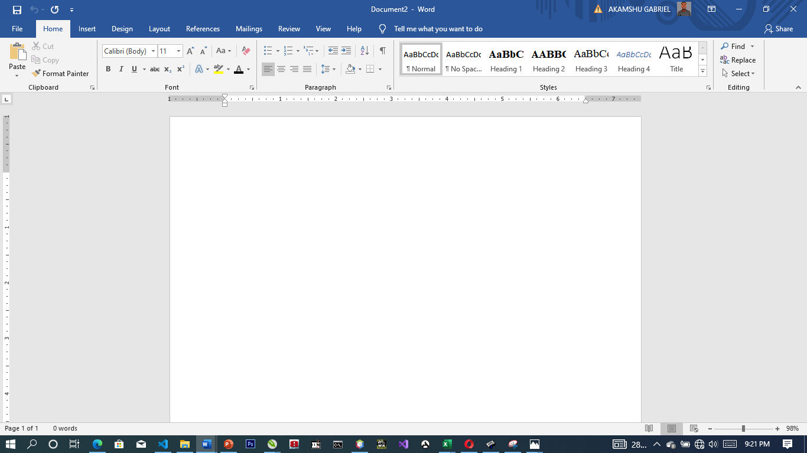

Figure 3.1: Microsoft Word Viewed Screen.

1. The title bar: wherever you saved any work, the file name and reside on the title bar
2. The menu bar: menu bar is made up of (file, edit, view, insert, format, tools, table, and window help).
3. The standard tool bar: consist of spelling and grammar icon, help.
4. The formatting tools bar: contain **(Bold (B), *(I), Italic* underline (U).**
5. **The drawing tools bar:** consist of any thin like auto shape, square, circle, text, word art pie chart, and bar chart etc.
6. **The insertion point:** or cursor is a place where you can insert table, row column etc.
7. **The ruler:** rule is mean for adjusting the MS-word environment etc.

**3.2 MICROSOFT EXCEL**

Microsoft Excel is a program that manipulates data in rows and columns. It enables you to store not only numerical data but also formulae to carry out operations on the numerical data. So a formula apply to one the spreadsheet may determine the values shown in another part. If data in one area of the spreadsheet is changed, the adjustment are made automatically to other area.

**3.2.1 DEFINATION OF SOME BASIC MICROSOFT EXCEL TERMS**

1. **Rows:** These run left to right across the windows and their position is designated by a number.
2. **Columns:** These run from top to bottom of the window and their position is designated by a letter.
3. **Cell Reference:** is formed by combining the column position and row position.
4. **Label:** is a text entry. We use label to identify what we are talking about.
5. Value: is piece of data that can be used in calculation.

**MICROSOFT OFFICE EXCEL 2013 WINDOW.**

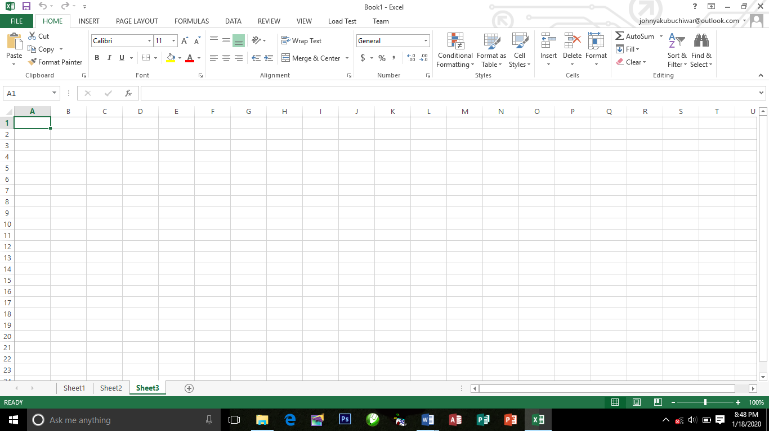

**SOME SPECIFICATION AND LIMITS IN EXCEL**

1. Number of Rows = 65,536
2. Number of Columns = 256 (from A to IV)
3. Columns can hold up to = 255 characters

**3.2.2 TYPES OF OPERATION IN EXCEL.**

Arithmetic operation:

To perform basic mathematical operation such as addition, subtraction, or multiplication, combine numbers, and produce numeric result, use the following arithmetic operations.

**Arithmetic operation Meaning (Example)**

+ (Plus sign) Addition (3+3)

- (minus sign) Subtraction (4-1)

* (asterisk) Multiplication (3*3)

/ (forward sign) Division (3/)

% (percent sign) Percent (20%)

^ (caret sign) Exponentiation (3^2)

SQRT Square root sqrt(19)

AVERAGE. Average of the rage of cells average (A1:A15)

**EXAMPLES:**

Formula in Microsoft excel to solve the following questions

1. 2+3
2. 32+52
3. 67-

**SOLUTION:**

=2+3

=3^2+52

=67-SQRT(23)

**HOW TO CALCULATE EMPLOYEE SALARY**

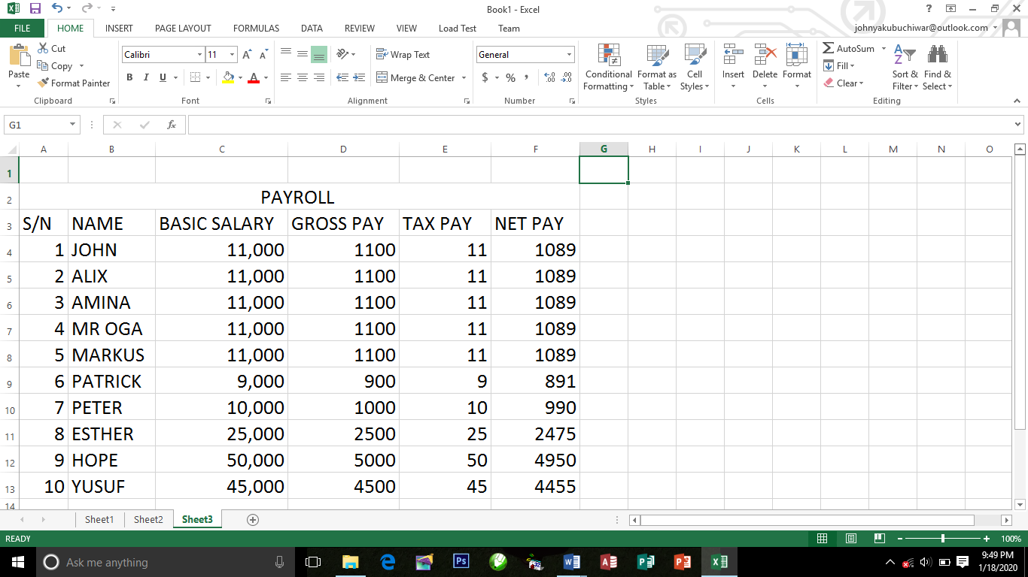

**HINT:**

1. Allowance = 10%* of Basic salary
2. Gross pay = Allowance + Basic salary
3. Tax pay = 1%* of Gross pay
4. Net par = Gross pay Tax pay

**HOW TO CALCULATE SUMIF:**

SJMIF is one the powerful tools in Excel that Enables you to add up the values in a rang that meet the criteria you specify.

EXAMPLE: To get sum of book, type exactly following formula:

**=SUMIF(C1:C10),”BOOK”,(D1:D10”)**

Examples:

The figure is shown list of goods in Column C OF the Excel window column D displays the cost of the items.

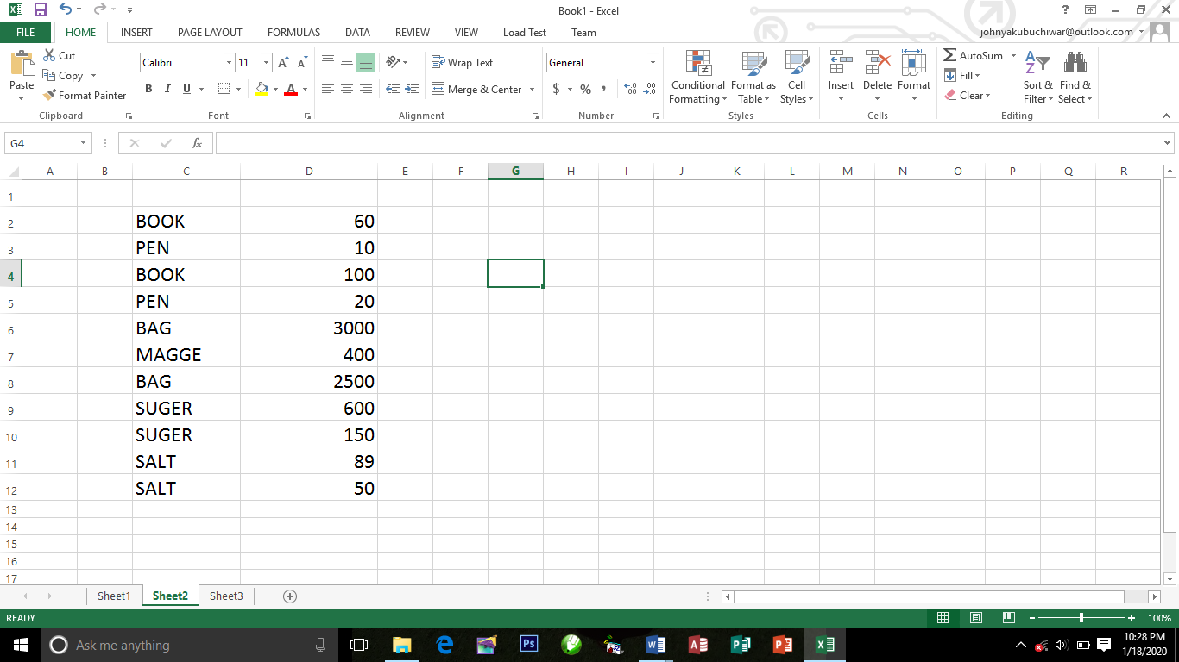

**HOW TO CALCULATE STUDENT RESULT.**

How to calculate student result using the conditional IF.

**EXAMPLE:**

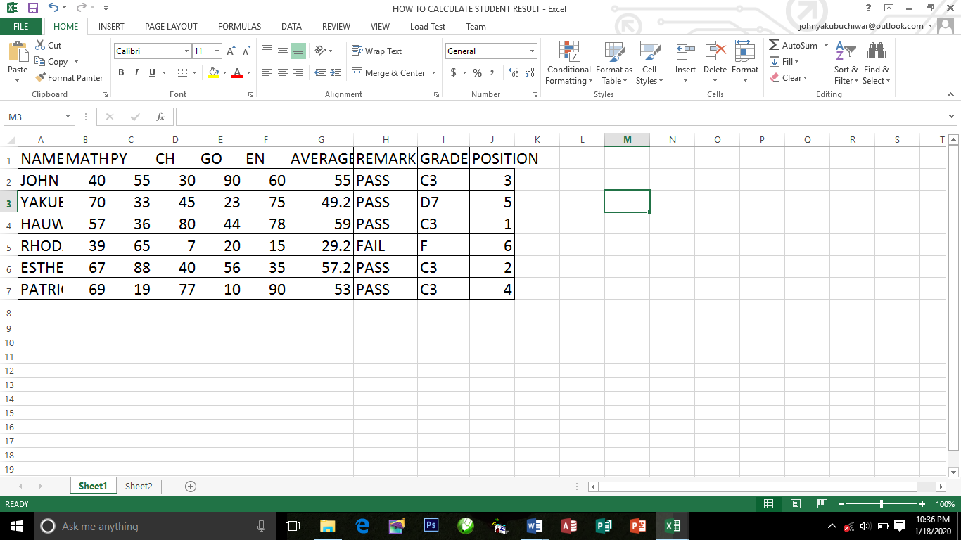

1. **The following: =Average(B2:G2)**

Will calculate the Average for John

1. **The following: =IF(G2>40,”PASS”,”FAIL”)**

Will calculate the Remark for John

1. **The following:**

=IF(G2>90,”A1”,IF(G2>85,”A2”,IF(G2>80,”A3”,IF(G2>70,”B1”,IF(G2>65,”B2”,IF(G2>50,”C3”,IF(G2>40,”D7”.IF(G2>35,”P”,”F”))))))))

Press enter on keyboard

Will calculate the Grade.

To get the result of the remaining students, I click G3 to I4

Then I click the Fill handle at G3 and drag it down to the last students.

**CHART**

Chart is a graphical representation of number. Chart have various types, but the most common chart are: BAR CHART AND PIE CHART.

**TO CREATE THE CHART**

1. Type the data you want to place in a chart
2. Select the data
3. Click insert on the menu bar
4. Click the chart type, e.g. pie chart
5. Click the chart layout

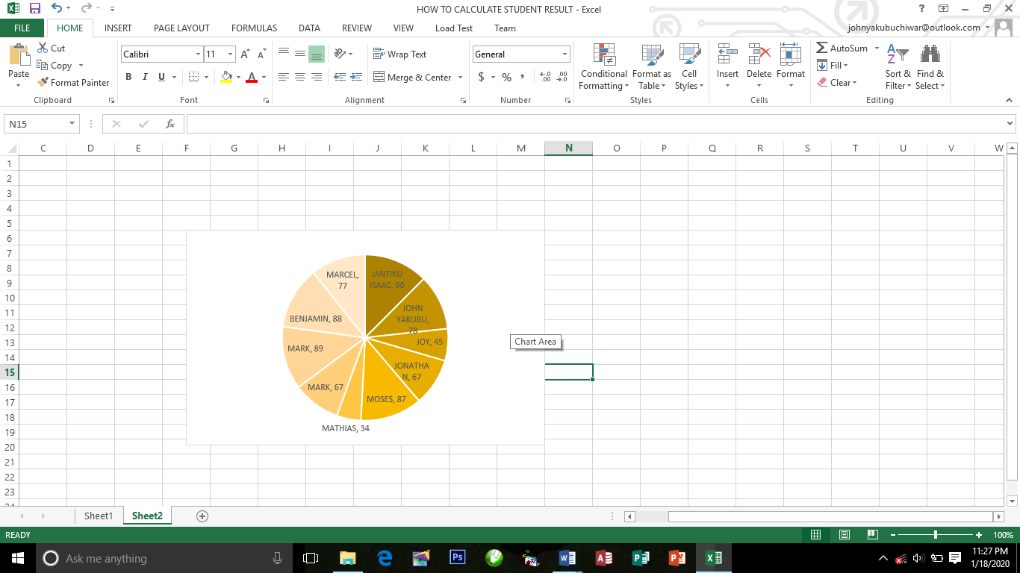

**3.3 INTRODUCTION TO NETWORKING**

Networking, also known as computer networking, is the practice of transporting and exchanging data between nodes over a shared medium in an information system. Networking comprises not only the design, construction and use of a network, but also the management, maintenance and operation of the network infrastructure, software and policies.

Computer networking enables devices and endpoints to be connected to each other on a local area network (LAN) or to a larger network, such as the internet or a private wide area network (WAN). This is an essential function for service providers, businesses and consumers worldwide to share resources, use or offer services, and communicate. Networking facilitates everything from telephone calls to text messaging to streaming video to the internet of things (IoT).

The level of skill required to operate a network directly correlates to the complexity of a given network. For example, a large enterprise may have thousands of nodes and rigorous security requirements, such as end-to-end encryption, requiring specialized network administrators to oversee the network.

At the other end of the spectrum, a layperson may set up and perform basic troubleshooting for a home Wi-Fi network with a short instruction manual. Both examples constitute computer networking.

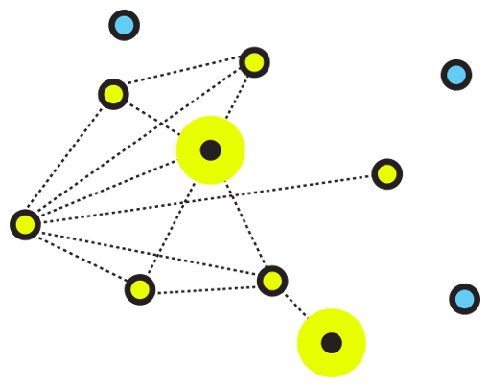

Figure 3.4: An illustrative image for networking

**3.3.1 Types of Networking**

There are two primary types of computer networking: wired networking and wireless networking.

Wired networking requires the use of a physical medium for transport between nodes. Copper-based Ethernet cabling, popular due to its low cost and durability, is commonly used for digital communications in businesses and homes. Alternatively, optical fiber is used to transport data over greater distances and at faster speeds, but it has several tradeoffs, including higher costs and more fragile components.

Wireless networking uses radio waves to transport data over the air, enabling devices to be connected to a network without any cabling. Wireless LANs are the most well-known and widely deployed form of wireless networking. Alternatives include microwave, satellite, cellular and Bluetooth, among others.

As a general rule, wired networking offers greater speed, reliability and security compared to wireless networks; wireless networking tends to provide more flexibility, mobility and scalability.

It should be noted that these types of networking concern the physical layer of the network. Networking can also be classified according to how it's built and designed, encompassing approaches that include software-defined networking (SDN) or overlay networks. Networking can also be categorized by environment and scale, such as LAN, campus, WAN, data center networks or storage area networks.

**3.3.2 Components of Networking**

Computer networking requires the use of physical network infrastructure -- including switches, routers and wireless access points -- and the underlying firmware that operates such equipment. Other components include the software necessary to monitor, manage and secure the network.

Additionally, networks rely on the use of standard protocols to uniformly perform discrete functions or communicate different types of data, regardless of the underlying hardware.

For example, voice over IP (VoIP) can transport IP telephony traffic to any endpoint that supports the protocol. HTTP provides a common way for browsers to display webpages. The internet protocol suite, also known as TCP/IP, is a family of protocols responsible for transporting data and services over an IP-based network.

**3.3.3 Networking wiring colour code and crimping.**

**How to make an ethernet cable**

Purchasing Ethernet cables can be quite expensive and pre-made lengths are not always the length you need.  Making Ethernet cables is easy with a box of bulk Category 5e Ethernet cable and RJ-45 connectors that are attached to the cut ends of your preferred cable length.

Bulk Ethernet Cable - Category 5e or CAT5e

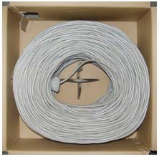

Figure 3.5: Bulk Ethernet Cable - Category 5e or CAT5e

(You may also use Category 6 or CAT6 cabling which has higher performance specifications and is about 20% more expensive than CAT5e.)

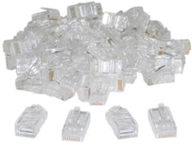

Figure 3.6: Bulk RJ45 Crimpable Connectors for CAT-5e

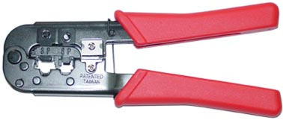

Figure 3.7: RJ-45 Crimping tool

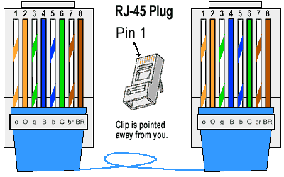

Figure 3.8: RJ45 diagram

**3.3.4 Types of ethernet cables**

There are two kinds of Ethernet cables you can make, **Straight Through**and **Crossover**.  
**Straight through** Ethernet cables are the standard cable used for almost all purposes, and are often called "patch cables". It is highly recommend you duplicate the color order as shown on the left. Note how the green pair is not side-by-side as are all the other pairs. This configuration allows for longer wire runs.

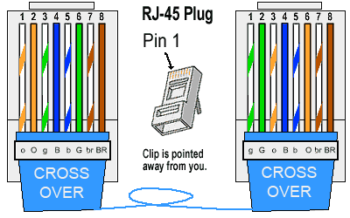

Figure 3.9: Straight through cable

**Crossover Cables** - The purpose of a Crossover Ethernet cable is to directly connect one computer to another computer (or device) without going through a router, switch or hub.

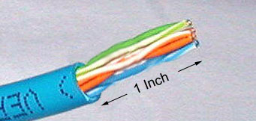

Figure 3.10: Cross over cable

Cut into the plastic sheath about 1inch (2.5 cm) from the end of the cut cable. The crimping tool has a razor blade that will do the trick with practice.

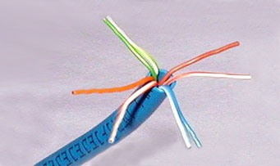

Figure 3.11: Unwind and pair the similar colors.

Pinch the wires between your fingers and straighten them out as shown. The color order is important to get correct.

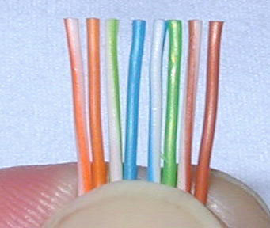

Figure 3.12: Colour order of cables

Use scissors to make a straight cut across the 8 wires to shorten them to 1/2 Inch (1.3 cm) from the cut sleeve to the end of the wires.



Figure 3.12: Scissors

Carefully push all 8 unstripped colored wires into the connector. Note the position of the blue plastic sleeve. Also note how the wires go all the way to the end.

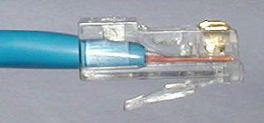

Figure 3.13: Inserting the wires

A view from the top. All the wires are all the way in. There are no short wires.

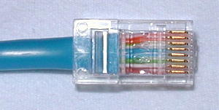

Figure 3.14: Top view of the inserted wires

**Wrong Way** - Note how the blue plastic sleeve is not inside the connector where it can be locked into place. The wires are too long. The wires should extend only 1/2 inch from the blue cut sleeve. Note how the wires do not go all the way to the end of the connector.

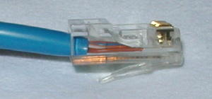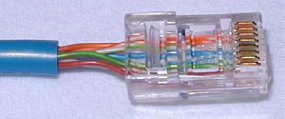

Figure 3.15: Wrong way of inserting the wires

**Crimping the Cable** ... carefully place the connector into the Ethernet Crimper and cinch down on the handles tightly. The copper splicing tabs on the connector will pierce into each of the eight wires. There is also a locking tab that holds the blue plastic sleeve in place for a tight compression fit. When you remove the cable from the crimper, that end is ready to use.

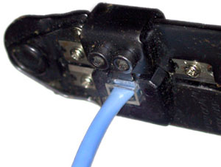

Figure 3.16: Crimping the cable

For a standard "Straight Through" cable, repeat all steps and wire color order on the other end of cable. For a cross-over cable, the other end will have a different color order as shown by the crossover picture above. Make sure to test the cables before installing them. An inexpensive Ethernet cable tester does this quite well.

**3.4 MICROSOFT POWERPOINT**

**3.4.1 WHAT IS MICROSOFT POWERPOINT**

Microsoft PowerPoint is one of the most popular technology that is being used by many of us in our day in day out to present our views in more attractive and precise way with numerous special effects. With a few clicks, user can add graphics, text, visuals, sounds and many more effects. In most of the Business meetings, PowerPoint presentation making the sessions more interesting for the listeners compared to old traditional way of representation.  Sometimes abbreviated as PP or PPT, PowerPoint is a presentation [program](https://www.computerhope.com/jargon/p/program.htm) developed by [Microsoft](https://www.computerhope.com/comp/msoft.htm) that creates a slide show of important information, charts, and images for a presentation. It is most often used for business and school presentations.

## 3.4.2 Powepoint Ribbon Tabs

The ribbon tabs group tools and features together based on their purpose. For example, to make your slides look better, look for options on the Design tab. The tools that you use to animate things on your slide would be on the Animations tab.

Here’s a look at what you’ll find in each of the PowerPoint ribbon tabs.

### 1. Home

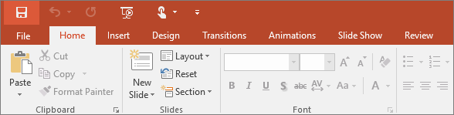

The Home tab holds the **Cut** and **Paste** features, **Font** and **Paragraph** options, and what you need to add and organize slides.

### 2. Insert

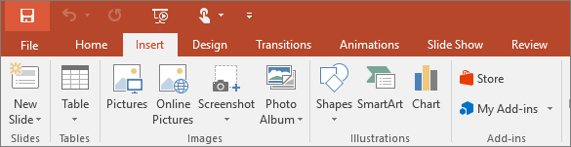

Click **Insert** to add something to a slide. This includes pictures, shapes, charts, links, text boxes, video and more.

### 3. Design

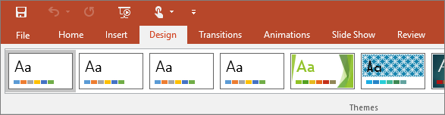

On the **Design** tab, you can add a theme or color scheme, or format the slide background.

### 4. Transitions

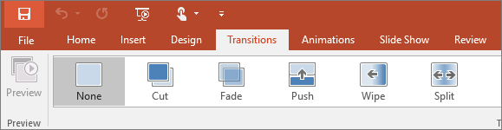

Set up how your slides change from one to the next on the **Transitions** tab. Find a gallery of the possible transitions in the **Transition to This Slide** group – click **More** More button at the side of the gallery to see all of them.

### 5. Animations

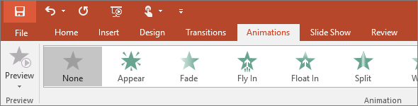

Use the **Animations** tab to choreograph the movement of things on your slides. Note that you can see many possible animations in the gallery in the Animation group, and see more of them by clicking **More** More button.

### 6. Slide show

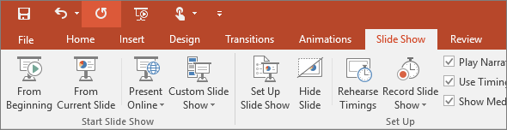

On the **Slide Show** tab, set up the way that you want to show your presentation to others.

### 7. Review

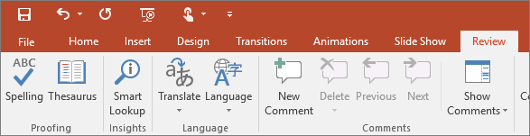

The **Review** tab lets you add comments, run spell-check, or compare one presentation with another (such as an earlier version).

### 8. View

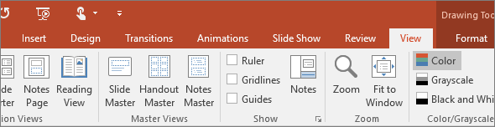

Views allow you to look at your presentation in different ways, depending on where you are in the creation or delivery process.

### 9. File

At one end of the ribbon is the **File** tab, which you use for the behind-the-scenes stuff you do with a file, such as opening, saving, sharing, exporting, printing and managing your presentation. Click the **File** tab to open a new view called the Backstage.

Click from the list on the side to do what you want to do; for example, click **Print** to find the options and settings for printing your presentation. Click Back Back to document to return to the presentation that you were working on.

### 10. Tools tab

When you click some parts of your slides, such as pictures, shapes, SmartArt or text boxes, you might see a colorful new tab appear.

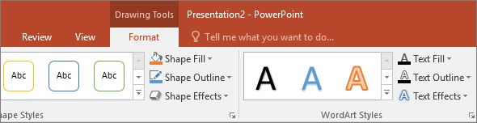

In the example above, the **Drawing Tools** tab appears when you click a shape or text box. When you click a picture, the **Picture Tools** tab appears. Other such tabs include SmartArt Tools, Chart Tools, Table Tools and Video Tools. These tabs disappear or change when you click something else in your presentation.

**HOW TO OPEN OR START POWERPOINT**

1. Click the Windows "Start" button, and then select “All Programs.”
2. Scroll through the list of folders that appear to find the folder labeled “Microsoft Office.”
3. Click that folder, and then click the “Microsoft PowerPoint” icon to open PowerPoint.

**How to start and stop a PowerPoint slide show**

After creating a set of slides or a presentation in [Microsoft PowerPoint](https://www.computerhope.com/jargon/p/powerpoi.htm), you can play the slides as a [slide show](https://www.computerhope.com/jargon/s/slidesho.htm), displaying them as [full screen](https://www.computerhope.com/jargon/f/fullscre.htm) on your computer. A PowerPoint slide show is an excellent visual aid when presenting important information and images to others on a web conference.

There are three ways to start a slide show in PowerPoint:

1. Open Microsoft PowerPoint, then open your presentation.
2. Click the Slide Show tab in the [Ribbon](https://www.computerhope.com/jargon/r/ribbon.htm).
3. To start the slide show from the first slide, click the From Beginning option in the Start Slide Show section.
4. To start the slide show from a slide other than the first, select that slide in your presentation, then click the From Current Slide option in the Start Slide Show section.

or

Open Microsoft PowerPoint, then open your presentation.

In the lower-left or lower-right area of the PowerPoint program window, click the Slide Show PowerPoint - Start slide show icon. The slide show starts from the currently-selected slide in your presentation.

or

1. Open Microsoft PowerPoint, then open your presentation.
2. To start the slide show from the first slide, press the [F5](https://www.computerhope.com/jargon/f/f5.htm) key.
3. To start the slide show from a slide other than the first, select that slide in your presentation, then press the [Shift](https://www.computerhope.com/jargon/s/shiftkey.htm)+F5 [key combination](https://www.computerhope.com/jargon/k/key-combination.htm).

**Stop a PowerPoint slide show**

To stop a slide show that is currently running in PowerPoint, press the [Esc](https://www.computerhope.com/jargon/e/esc.htm) key. Upon doing so, the slide show ends and the PowerPoint program window is displayed again.

# CHAPTER FOUR

# SUMMARY, CONCLUSION, PROBLEMS AND RECOMMENDATIONS

## 4.1 SUMMARY

The relevance of the SIWES program cannot be over emphasized considering the fact that it has significantly reduced the gap between my theoretical and practical knowledge about computer hardware and software, installations, maintenance and networking. The processes of communication which include data and telecommunication the use of switch in the networking and what networking is all about.

The program is indeed a commendable one in that it affords students ample opportunities of being exposed to good working relationship with colleagues and the field experience with customers. This little exposure has widened my knowledge about my course of study, not only that it has automatically changed my views about lift in general. The firm at large has taught me how to be independent of my own how to be conscious of my health and safety at its peak relating to the environment where I carried out my SIWES program. It was indeed a highly rewarding experience to be with Moving Tech, Yola, Adamawa State.

**4.2 CONCLUSION**

In conclusion, I thank ITF in general for their effort towards the Student Industrial Training Scheme. The contribution that the industrial training offered to student will not be over emphasized. It has exposed me seriously to a certain depth and length of practical capability on Computer Knowledge and practical Know how.

It has also acquainted me with the working condition, which I am expected to encounter in the near future. I will say that SIWES has a greater advantage on me, it has greatly exposed me to the practical application of all that I have been through in the school, SIWES is an experience that all student must pass through this is because it gives a full practical knowledge of what has been through in classroom.

Finally, I have a strong believe that this comprehensive based on the experience, I acquired during the industrial training scheme will convince every user training is not difficult.

I therefore strong conclude that the continuous existence of SIWES programme as it is very necessary since it plays a dominant role in the development of student of Computer Science in the acquisition of practical experience.

## 4.3 PROBLEMS OBSERVED DURING MY PROGRAM

1. The time frame set for the program is too short as some of the aspects of the program where not completed.
2. Lack of Financial support from the company to aid transportation to and from training.
3. Attentions are not given to the IT students by the workers it is learn if you want to learn or ask if you want to know.
4. Cost of Training: The Student has to be registered as a student of a particular organization in order to carry out the program.

**4.4 RECOMMENDATIONS**

Below are the recommendations that should be given serious consideration so as alleviate the suffering of students undergoing SIWES.

Firstly, the Federal Government of Nigerian should make a positive effort in reducing the overall cost of production so that companies should be producing to fill capacity and accommodate SIWES populaces. Also, certain monthly allowance may be given to the student by company accepted then (student to ease transportation problem).

Secondly, the Industrial Training Fund (ITF), should try and increase the money paid at the end of SIWES to the student so as to justify the Cost of Living we experienced.

Finally, the ITF official should please continue visiting the students, to ensure that what they are learning is in line with the ITF requirement.

**REFERENCES**

Edward, B. M.D (2003). The Effect of SIWES on a student, Federal Ministry of Works, Lagos. Nigeria.

John, Doe (2008). Introduction to web development: responsive designs, McGraw Print New York.